React Lab – Event Handling in React

# Objectives

• Explain React events  
• Explain about event handlers  
• Define Synthetic event  
• Identify React event naming convention

# Hands-On Lab Summary

In this lab, a React application named “eventexamplesapp” demonstrates event handling, the use of `this` keyword, synthetic events,   
event handlers with parameters, and form submission with event prevention.

# Output Screenshot

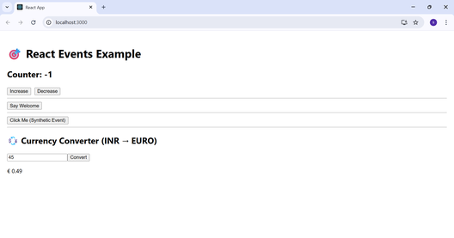

# App.js

import React, { Component } from 'react';  
import CurrencyConvertor from './CurrencyConvertor';  
  
class App extends Component {  
 constructor(props) {  
 super(props);  
 this.state = { count: 0 };  
 this.sayHello = this.sayHello.bind(this);  
 }  
  
 increment = () => {  
 this.setState(prev => ({ count: prev.count + 1 }));  
 this.sayHello();  
 };  
  
 sayHello() {  
 alert("Hello! You clicked the Increase button.");  
 }  
  
 decrement = () => {  
 this.setState(prev => ({ count: prev.count - 1 }));  
 };  
  
 sayWelcome = (msg) => {  
 alert(msg);  
 };  
  
 handleClick = (event) => {  
 alert("I was clicked (Synthetic Event)");  
 console.log("SyntheticEvent Type:", event.type);  
 };  
  
 render() {  
 return (  
 <div style={{ padding: '20px' }}>  
 <h1>🎯 React Events Example</h1>  
 <h2>Counter: {this.state.count}</h2>  
 <button onClick={this.increment}>Increase</button>  
 <button onClick={this.decrement} style={{ marginLeft: '10px' }}>Decrease</button>  
 <hr />  
 <button onClick={() => this.sayWelcome("Welcome to React!")}>Say Welcome</button>  
 <hr />  
 <button onClick={this.handleClick}>Click Me (Synthetic Event)</button>  
 <hr />  
 <CurrencyConvertor />  
 </div>  
 );  
 }  
}  
  
export default App;

# CurrencyConvertor.js

import React, { Component } from 'react';  
  
class CurrencyConvertor extends Component {  
 constructor(props) {  
 super(props);  
 this.state = {  
 rupees: '',  
 euro: ''  
 };  
 }  
  
 handleInput = (event) => {  
 this.setState({ rupees: event.target.value });  
 };  
  
 handleSubmit = (event) => {  
 event.preventDefault();  
 const rupees = parseFloat(this.state.rupees);  
 if (!isNaN(rupees)) {  
 const euro = rupees * 0.011;  
 this.setState({ euro: euro.toFixed(2) });  
 }  
 };  
  
 render() {  
 return (  
 <div>  
 <h2>💱 Currency Converter (INR → EURO)</h2>  
 <form onSubmit={this.handleSubmit}>  
 <input  
 type="number"  
 placeholder="Enter amount in ₹"  
 value={this.state.rupees}  
 onChange={this.handleInput}  
 />  
 <button type="submit">Convert</button>  
 </form>  
 {this.state.euro && <p>€ {this.state.euro}</p>}  
 </div>  
 );  
 }  
}  
  
export default CurrencyConvertor;

# Explanation

• `onClick` is used for button clicks to trigger class methods.  
• `bind(this)` and arrow functions ensure correct `this` reference.  
• SyntheticEvent is used internally by React for consistent event handling.  
• Form submission is handled with `onSubmit` and prevented with `event.preventDefault()`.  
• React naming convention uses camelCase (e.g., onClick, onSubmit).